Comparative World Religions 12 Course Outline
Land Acknowledgment
We respectfully acknowledge that we live, learn, and work on the traditional and unceded territory of the hən̓q̓əmin̓əm̓-speaking peoples of the Tsawwassen First Nation and Musqueam First Nation.
As we engage in learning, we commit to reflecting on the history, resilience, and ongoing contributions of Indigenous peoples and to walking forward in the spirit of truth, respect, and reconciliation.
Overview of Course
Comparative World Religions 12 is guided by a set of big ideas and a competency-based approach to understanding belief systems across the world and throughout human history. Students will learn to understand concepts then use their understanding to address real-world issues. The core of the course is for the student to become an independent learner by going through abstract and complicated subjects and ultimately develop a sophisticated understanding of these concepts.
Keep in mind that this course is comparative in nature. For this reason, it is organized thematically rather than by religion. Of note is the fact that there is no unit on Buddhism or Christianity. Instead, students will compare places of worship amongst religions as well as holy texts and food taboos. All of this is with a BC New Curriculum understanding of Curricular and Core Competencies.
Unit Breakdown
Unit | Themes | Assignment Breakdown
Introductory Unit | - Introduction to Comparative World Religions | - Introductory Learning Guide  Introductory Assignment
Unit 1 – Foundations | - What is Religion?  - First Peoples’ Spirituality  - Defining beliefs, symbols, sacred places. | - Unit 1 Learning Guide  - Origins Assignment  - Creation Myth Assignment  - Pantheon Assignment  - Mythical Creatures Assignment  - Unit Test
Unit 2 – Comparative Beliefs | - Core tenets of key religions (e.g., Five Pillars, Dharma)  - Rituals, festivals, ethics.  - Scriptural influences. | - Unit 2 Learning Guide  - Sacred Texts Assignment  - Beliefs and Morality Assignment  - Holidays and Ceremonies Assignment  - Holy Places and Pilgrimage Assignment  - Unit Test
Unit 3 – Institutions & History | - Leadership roles (imams, popes, councils).  - Institutional structures (churches, mosques)  - Historical developments, religious spread. | - Unit 3 Learning Guide  3.1 Aniconism and Architecture Assignment  3.2 Visual Art Assignment  3.3 Music and Religion Assignment  3.4 Learning to Dance Assignment  2. Unit Test
Unit 4 – Religion in Society | - Artistic/architectural evidence.  - Religion and government relationships.  - Media representation, current issues, media literacy. | - Unit 4 Learning Guide  4.1 Religion and Government Assignment  4.2 Religion in the Media Assignment  4.3 Non-belief Assignment  4.4 Religion’s Future Assignment  2. Unit Test

Learning Guides (Worth 20% of overall mark)
Learning Guides are to be completed while working through the unit curriculum. The Learning Guide MUST BE SUBMITTED prior to taking the unit test. ALL submissions must be laid out in a neat, well-organized manner. The spacing is meant as a guide for your responses and you will be expected to go into as much detail as necessary to fully answer the questions. All definitions are expected to be completed.
The following rubrics will be used to mark your Learning Guide:
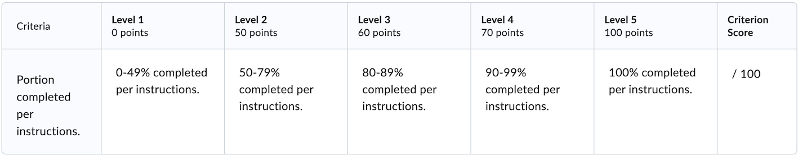

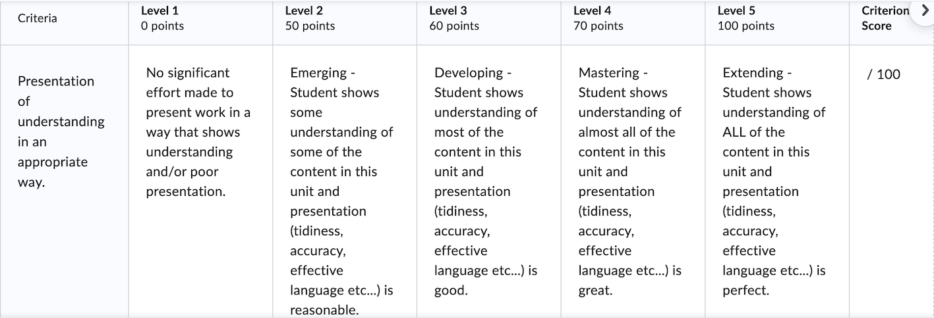
Assignments (Worth 40% of overall mark)
Each unit has 4 assignments. These assignments allow students to synthesize the ideas presented in the section. Students should review the instructions for each assignment carefully and reach out to the teacher if you need clarification.
- You are expected to view the rubric before submitting.
- Make sure you meet ALL assignment criteria before handing it in for marking.
- READ ALL FEEDBACK COMMENTS.
Unit Tests (Worth 40% of the overall mark)
All tests are “closed book” and will require supervision. You cannot write a unit test without having submitted your Learning Guide first. You will need to book a time to write the unit test at the appropriate testing centre.

Important Notes for Success in Comparative World Religions 12
- SET UP PACING & PROGRESS PLAN
- Start at the beginning of the course and work your way through the units in the order that appears for each unit. Some assignments may only show once you have viewed the curriculum.
- Actively work through each section, including clicking on ALL parts of the curriculum and complete the learning guide while going through the content.
- Use the learning guide as your tool for documenting your understanding. Lay it out in a neat, well-organized manner.
- Complete each assignment as you finish each section. Do NOT jump around the course.
- Review the feedback you get on your Learning Guide before writing the unit test.
- Use the message system to email your teacher (OR directly email me at tduggan@deltaschools.ca) for prompt response.

