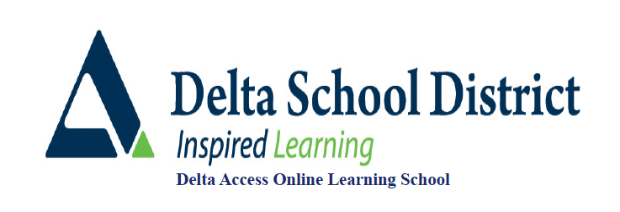

**Fashion Industry 12**

COURSE OUTLINE

**Overview**

Fashion Industry 12 is a course that is rich in content which provides a solid foundation for students to build individual projects. Three units including “What is Fashion, The Business of Fashion and Fashion Design combine to inform the student who then showcases their understanding in a series of Projects. This course is delivered entirely online, there are no supervised tests for this course.

**Prerequisites:** None

**Course Content and Timelines**

The timelines suggested are based on a 10 month Fall course September to June. If you are taking a Spring/Summer course (5 months) or joining a course with less time left, you will want to adjust your timing accordingly

**Unit 1: What is Fashion (September to Mid-November – about 8 weeks)**

**Unit 2: The Business of Fashion (Mid-November to Mid-January – about 8 weeks)**

**Unit 3: Fashion Design (January to Mid-March about 8 weeks)**

**Unit 4: Fashion Projects (March to end of June about 12 weeks)**

**Course Materials**

No textbook is required. Course content is delivered on our D2L platform.

**Assessment Information**

|  |  |
| --- | --- |
| **Learning Guides** | **40%** |
| **Projects** | **60%** |

**Learning Guides**

All units contain a learning guide for students to work through as they read the course materials. Once a learning guide has been completed students should upload their work and submit it for marking. Before you start Unit 4 Projects, you must submit the Learning Guides for Unit 11,2 and 3.

**Projects**

Use the course choice projects to enhance your understanding in areas of interest. Make sure you carefully select projects that interest you and that you are excited about. If you do not find projects that excite you then brainstorm your own potential Fashion Project or Projects and run your ideas by your instructor.

**Reporting**

**Weekly Progress Reports**

These be sent to both students and parents through the D2L website. These reports are sent via email and are based on information provided on course introduction forms. Please make sure your D2L profile is up to date with this information to ensure these are received. If you need assistance with this, please contact your teacher to help you make sure you are getting these reports.

**Report Cards**

These will be issued for the Fall term in November, March and June. For Spring/Summer only a final report card will be issued in August. These reports are available for Delta School District students on student and parent connect. For those not attending one of our high schools please call our Continuing Education office 604-940-5550 to have a copy sent.

Only students who have done enough work to meet the activity requirement for the course will get report cards by the term deadlines outlined by their teachers. Even if you are getting progress reports you are not considered an active (official student) until this is met. For this course you must complete the Local Venues, Lifelong Activities, and the Benefits of Active living assignments. All three must be submitted and assessed for the activity requirement to be met.

Course reports are based on only what has been submitted for the Fall until April 1st and for the Spring/Summer until July 15th. At this time all missing assignments will count in grade calculations giving students a realistic picture of current course standings. It is important when viewing report cards and progress reports up until this point that the amount of the course completed is taking into consideration. (ie. 90% standing in a course that is only 10% complete is very different than 90% in a course that is 80% complete)

**Plagiarism**

**Plagiarism and Academic Dishonesty**

*Plagiarism* *is the unauthorized use or close imitation of the language and thoughts of another author and the representation of them as one’s own original work, as by not crediting the author*(Dictionary.com) <http://dictionary.reference.com/browse/plagiarism>

Plagiarism can be done either intentionally or accidentally. Regardless, it is an academic offence that carries with it varying levels of consequences – from a mark of zero for work submitted to expulsion from the course and/or on-line program. Plagiarism takes various forms: copying another’s work, not citing another’s original work, cutting and pasting from the internet and claiming the work as your own, allowing other students to copy and submit your work as their own, and so on. It is YOUR RESPONSIBILITY to be aware of the rules around using and citing other people’s work.

An excellent website that answers questions about plagiarism can be found at:

<http://www.plagiarism.org/>  
<http://www.grammarly.com/>  
<http://www.englishclub.com/writing/plagiarism.htm>  
<http://australianhelp.com/plagiarism>

If you are uncertain as to whether you may be plagiarizing someone’s work, check with your teacher or consult the many websites that outline the rules.

If a student is found to have submitted plagiarized work, the Delta Access teacher will notify both the student and Delta Access administration to document the violation and to determine further consequences. Repeated occurrences of plagiarism will likely result in a final mark of “Failure” in the specific on-line course.

**Contacting your teacher**

You can email me anytime at [dscarr@deltaschools.ca](mailto:dscarr@deltaschools.ca)

If you have any concerns that cannot be addressed by your teacher please contact Delta Access – [svangeemen@deltaschools.ca](mailto:svangeemen@deltaschools.ca)   or call 604-599-6398