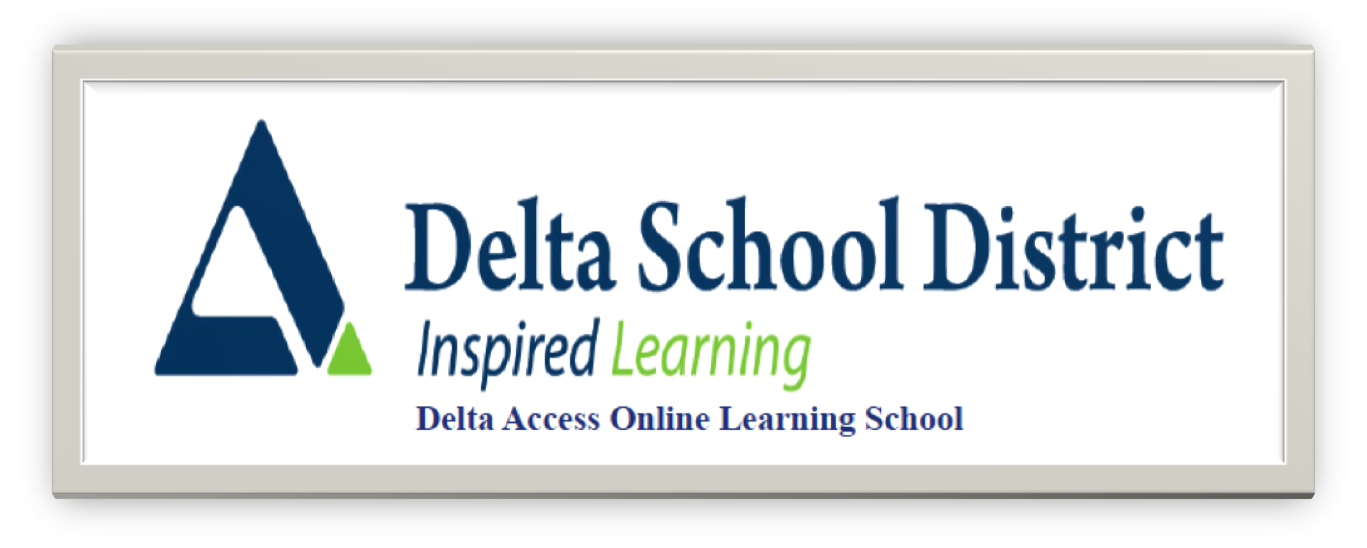
Contemporary Indigenous Studies 12
Course Outline

Teacher: Ms. Matthews (contact at: dmatthews@deltalearns.ca)

Course Layout: The course is broken down as follows:

Unit | Topic
1 | Land, Language, & Identity
2 | Reclamation of Indigeneity
3 | Self-Determination & Advocacy
4 | Reconciliation & Healing

Grading: Your grade for this course will be calculated as follows:

Item | Weight
Projects | 60%
Learning Guides | 20%
Activities | 20 %

Prerequisites

Strong reading and writing English language skills are recommended, but there are no required prerequisites. You should have successfully completed Social Studies 8, 9 ad 10 prior to beginning this course.

Projects

As you work through units use the projects to enhance your understanding in areas or interest and/or weakness. Make sure you incorporate aspects of the unit readings as well as your own research into the final product for each unit project. It is required that you include a Bibliography for each project. You should be using Chicago/Turabine style as this is a Social Studies course although you do have the option of using APA as long as your citation style is consistent. Please see the OWL Purdue website for a citation guide for Chicago style or the APA style.

Keys to Success

- Actively work through each lesson, trying examples and reflecting on material.
- Use the readings and your own independent research to fully understand the concepts in the course. The course is set up so that you must do the readings in order to access assignments and projects so spread the work out and give yourself sufficient time to do the readings.
- Make sure you understand all project requirements. If you can't figure it out - ASK! Make sure to look at the rubric for each assignment or project to ensure you have everything presented properly. If your assignment or project references a visual or an auditory aspect, that must be incorporated into the project.
- Include all your planning as a separate document – this is essential in order to verify the authenticity of your work.
- All assignments are assessed only once – do it once and do it right; use the feedback given to improve on future submissions.
- Be sure to use the email listed above to communicate with your instructor – dmatthews@deltalearns.ca
- You will receive regular updates on your progress in the course but you can also access your current grade and progress through the actual course – do not email me in between updates to check your progress as you can do that yourself!

Reporting

Weekly Progress Reports
These be sent to both students and parents through the website. These reports are sent via email and are based on information provided on course introduction forms. Please make sure your profile is up to date with this information.

**Only students who have done the activation assignment will be able to view subsequent material for the course. This is one of the unique features of D2L.

What does this mean? Even if you are getting progress reports you are not considered an active (official student) until you have completed the activation assignment.

Report Cards
These will be issued for the Fall term in November, March and June. For Spring/Summer only a final report card is issued in August.

These reports are available for Delta School District students on student and parent connect. For those not attending one of our high schools. Please call our Continuing Education office 604-940-5550 to receive a copy.

Course reports are based on only what has been submitted for the Fall until April 1st and for the Spring/Summer until July 15th. At this time, all missing assignments will count in grade calculations; this gives students a realistic picture of current course standings.

It is important when viewing report cards and progress reports up until this point that the amount of the course completed is taking into consideration. (ie. 90% standing in a course that is only 10% complete is very different than 90% in a course that is 80% complete).

Academic Integrity/ Misconduct

Academic misconduct covers a wide array of behaviors in which a student gains or attempts to gain some type of unfair academic advantage in a course or on a specific assignment. It is often widely referred to as academic integrity. Failure to adhere to academic integrity results in misconduct and can include intentional or unintentional plagiarism (copying the work of another student), not acknowledging sources for information used in writing, using notes on an assessment, or even making your work accessible to another student for the purpose of copying the information (collusion).
Plagiarism and Academic Misconduct
Plagiarism is the unauthorized use or close imitation of the language and thoughts of another author and the representation of them as one’s own original work, as by not crediting the author (Dictionary.com) http://dictionary.reference.com/browse/plagiarism
Plagiarism can be done either intentionally or accidentally. Regardless, it is an academic offence that carries with it varying levels of consequences – from a mark of zero for work submitted to expulsion from the course and/or on-line program. Plagiarism takes various forms: copying another’s work, not citing another’s original work, cutting and pasting from the internet and claiming the work as your own, allowing other students to copy and submit your work as their own, and so on. It is YOUR RESPONSIBILITY to be aware of the rules around using and citing other people’s work.

ChatGPT or AI
Use of the new AI technology ChatGPT or AI is also in violation of the Delta Access Plagiarism policy. If student work is suspected to be produced with artificial intelligence it will be run through one of our AI checkers to confirm. If confirmed it will be treated the same as any other plagiarism violation.
An excellent website that answers questions about plagiarism can be found at:
http://www.plagiarism.org/
http://www.grammarly.com/
http://www.englishclub.com/writing/plagiarism.htm
http://australianhelp.com/plagiarism
If you are uncertain as to whether you may be plagiarizing someone’s work, check with your teacher or consult the many websites that outline the rules.
If a student is found to have submitted plagiarized work, the Delta Access teacher will notify both the student and Delta Access administration to document the violation and to determine further consequences. Repeated occurrences of plagiarism will likely result in a final mark of “Failure” in the specific on-line course.
Please see the Delta Access Plagiarism policy for full details (https://www.deltaaccess.ca/plagiarism/)

Contacting your Teacher

Ms. Matthews is available to answer your questions and help you if you are struggling. Please email me at dmatthews@deltalearns.ca and I will get back to you within 24 hours. Consistent communication with your teacher is key to success in a DL course. Email for help whenever necessary. When you email me, please be sure to tell me your legal name, your course title and level, eg. Dhana Matthews, EFP 11.

If you have any concerns that cannot be addressed by your teacher, please contact Delta Access directly – deltaaccess@deltasd.bc.ca or call 604-599-6398.

Frequently asked questions: https://www.deltaaccess.ca/faq/

Booking a test: https://www.deltaaccess.ca

