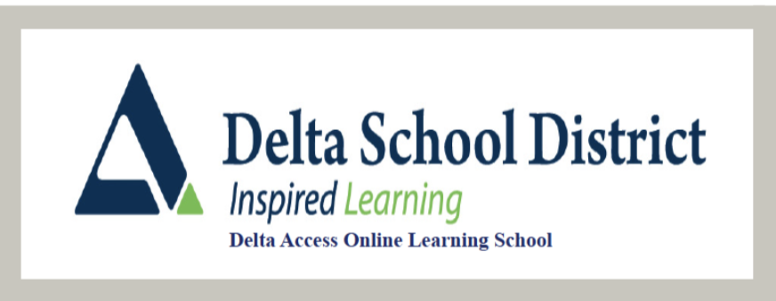

**Apprenticeship Math 12**

**Ms. Bousserska**

***dbousserska@deltaschools.ca***

**Course Outline**

**Course Overview**

**Apprenticeship Math 12** is a career-focused course for students interested in trades programs. The goal of this course is to provide students with the mathematical understanding and critical-thinking skills. It covers [measurement](https://www.google.com/search?client=firefox-b-e&sca_esv=0b20fb92276ee81d&cs=0&sxsrf=AE3TifMji65QB4JurDArc9fG1LqTh9teSA%3A1756293957690&q=measurement&sa=X&ved=2ahUKEwjZ8r7r8KqPAxXbFTQIHdEsCzMQxccNegQIBBAC&mstk=AUtExfDTa23-IcR_y5QNW_jTGYI3JYvU7mvBP-ngLORia-43tbcrsawKB7kUQ_-k1IglhFpcD8bZwdwUgVlA7VivOgiIHYIZr8q_h_kpwU-rttqlsLaFCVD2xnXk6scClHegdKsgFeENwbMNr84eGXfGZ7BsHxQDp0sFl2o2ki_7lK_fS50l9GVigWChgnTTfrVCj50trraBatulZbtXo_MiAZMnJizqacOr5VsS6ZVQuxqJu3c4ba53EJUVzL6qV-j-VEgJlhnmXLvyxQ5A7faWz7rp&csui=3), [geometry](https://www.google.com/search?client=firefox-b-e&sca_esv=0b20fb92276ee81d&cs=0&sxsrf=AE3TifMji65QB4JurDArc9fG1LqTh9teSA%3A1756293957690&q=geometry&sa=X&ved=2ahUKEwjZ8r7r8KqPAxXbFTQIHdEsCzMQxccNegQIBBAD&mstk=AUtExfDTa23-IcR_y5QNW_jTGYI3JYvU7mvBP-ngLORia-43tbcrsawKB7kUQ_-k1IglhFpcD8bZwdwUgVlA7VivOgiIHYIZr8q_h_kpwU-rttqlsLaFCVD2xnXk6scClHegdKsgFeENwbMNr84eGXfGZ7BsHxQDp0sFl2o2ki_7lK_fS50l9GVigWChgnTTfrVCj50trraBatulZbtXo_MiAZMnJizqacOr5VsS6ZVQuxqJu3c4ba53EJUVzL6qV-j-VEgJlhnmXLvyxQ5A7faWz7rp&csui=3), scale drawings, trigonometry, and financial literacy (loans, investments, business) to develop critical thinking and problem-solving skills for real-world trades and life situations. The course emphasizes hands-on application, data analysis, and communication of mathematical ideas. As this course is delivered online, it is crucial that students understand the responsibility that comes with this format. All assignments must be submittedon the DL2 platform, and tests and the final exam are supervised in the Delta Access Testing Centre. If you are unsure if this course is for you**,** please consult your counsellor. Remember, all students are expected to strive for their best**,** and extra help is always available from various sources.

**Prerequisites:** Workplace Mathematics 11

**Course Content and Timelines**

The timelines suggested are based on a 10 month Fall course (September to June). If you are taking a Spring/Summer course (5 months) or joining a course with less time left you will want to adjust your timing accordingly

**Unit 1:** Measurements and Limits to Mathematics (7 weeks)

**Unit 2:** Trigonometry and Similar Triangles (7 weeks)  
**Unit 3**: Surface Area and Volume (7 weeks)  
**Unit 4:** Isometric and Orthographic Projections of 3-D Objects (7 weeks)  
**Unit 5:** Owning a small business (7 weeks)

**Course Materials**

No textbook is required. Course content is delivered on DL2 platform by videos, online links and associated worksheets.

**Course Additional Resources**

* <http://www.bcmath.ca>
* <https://www.khanacademy.org>
* <http://www.mathtv.com>
* <http://patrickjmt.com>
* <https://cemc.uwaterloo.ca>

**Assessment Information**

|  |  |
| --- | --- |
| **Review Assignments (from home)** | **30%** |
| **Quizzes (from home)** | **10%** |
| **Unit Tests (supervised)** | **20%** |
| **Midterm Exam (supervised)** | **15%** |
| **Final Exam (supervised)** | **15%** |
| **Projects (from home)** | **10%** |

**Assignments**

Each unit contains one or multiple assignments, and it is imperative that students read the instructions and grading rubrics for each assignment carefully. Once the assignments are completed, they must be uploaded into the assignment submission box for marking. The most effective method of submission is through PDFs.

**Tests and Exams**

All tests and exams must be written under supervision. Students must sign up at one of the test centers to write the tests/exams using the school website www.deltaaccess.ca and click on the Book a Test.

**Quizzes**

Quizzes for each unit can be written by students in their own time, without the need for supervision. This flexibility allows students to manage their time effectively and complete these assessments when it best suits their schedule.

**Reporting**

**Bi-Weekly Progress Reports**

These will be sent to both students and parents through the online website. These reports are sent via email addresses provided on the course introduction forms filled out. Please ensure your online profile is current with this information to ensure these are received. If you need assistance with this, please get in touch with me to make sure you are getting these reports.

**Report Cards**

These will be issued for the Fall term in November, March and June. For Spring/Summer, only a final report card will be issued in August. These reports are available for Delta School District students on Student and Parent Connect. For those not attending one of our high schools, please call our Continuing Education office at 604-940-5550 to have a copy sent.

Only students who have done enough work to meet the activity requirement for the course will get report cards by the term deadlines outlined by their teachers. Even if you are getting progress reports, you are not considered an active (official student) until this is met.

Course reports are based on only what has been submitted for the Fall term until April 1st and July 15th for the Spring/Summer term. At this time, all missing assignments will count in grade calculations, giving students a realistic **picture** of current course standings. It is essential when viewing report cards and progress reports up until this point that the course completed amount is considered. (i.e. 90% standing in a course that is only 10% complete is very different than 90% in a course that is 80% complete)

**Contacting your Teacher**

You can email me anytime at dbousserska@deltaschools.ca