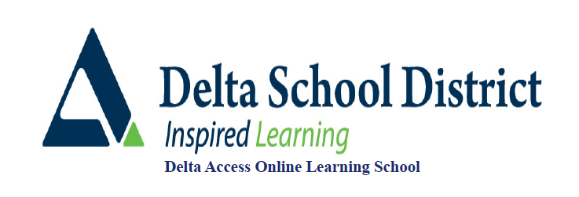

**Spanish 11**

COURSE OUTLINE

**Overview**

Spanish 11 will allow students to continue to develop an appreciation of the Spanish language and culture and further develop communicative competencies in the four strands of language learning: reading, writing, listening, and speaking. Students will expand their vocabularies and learn grammar concepts through the use of multiple language-learning platforms. Students’ progress on these platforms will be assessed throughout the course. Students will also be assessed on their written and spoken Spanish as well as their understanding of Spanish texts and audio clips.

**Prerequisites:**

None but successful completion of Intro Spanish 11 is recommended.

**Course Content and Timelines**

The timelines suggested are based on a 10 month Fall course September to June. If you are taking a Spring/Summer course (5 months) or joining a course with less time left you will want to adjust your timing accordingly.

**Unit 1: Food (8 weeks)**

**Unit 2: Interests (8 weeks)**

**Unit 3: History (8 weeks)**

**Unit 4: Short Stories (8 weeks)**

**Unit 5: Travel (8 weeks)**

**Assessment Information**

|  |  |
| --- | --- |
| **Language & Practice Activities** | **For Practice** |
| **Grammar Quizzes** | **20%** |
| **Vocabulary** | **5%** |
| **Reading Logs** | **5%** |
| **Reading Comprehension** | **10%** |
| **Speaking** | **20%** |
| **Listening & Viewing Logs** | **5%** |
| **Listening** | **15%** |
| **Projects** | **20%** |

**Unit Assignments**

There are unit assignments for this course. All instructions of assignments as well as evaluation rubrics are contained within the description. Once the assignments are complete, they are to scanned (if needed) and uploaded to the assignment submission boxes for marking.

**Final Submissions**

As part of your final unit, you will be required to video record yourself presenting a ten minute skit in French More information as well as the evaluation rubric for this conversation are contained within the description.Submit your video under “Conversation Dropbox.” You can submit the video directly into this dropbox if it fits. If the video file is large, you can paste a link (ie. Google link) into a Word or PDF document, and submit that into the dropbox instead.

**Reporting**

**Viewing Progress:**

Students, you must set up your PACING & PROGRESS widget. This video covers it all:

vimeo.com/1015077961?share=copy

**Report Cards**

These will be issued through MyEd for the Fall term in November, March and June. For Spring/Summer, only a final report card issued in August will be done.

Only students who have done enough work to meet the activity requirement for the course will get report cards by the term deadlines outlined by their teachers. You are not considered an active (official student) until this is met. For Spanish 11, the first assignment “Spanish Food Project” must be submitted and assessed for the activity requirement to be met.

It is important when viewing report cards and progress reports that the amount of the course completed is taking into consideration. **(ie. 90% standing in a course that is only 10% complete is very different than 90% in a course that is 80% complete.)**

### ChatGPT or AI

Use of the new AI technology ChatGPT or AI is also in violation of the Delta Access Plagiarism policy. If student work is suspected to be produced with artificial intelligence it will be run through one of our AI checkers to confirm. If confirmed it will be treated the same as any other plagiarism violation<https://www.deltaaccess.ca/plagiarism/>

If you have any questions about these, please contact: btereposky@deltaschools.ca

**Contacting your Teacher**

[ayap@deltaschools.ca](mailto:ayap@deltaschools.ca)

* If you have any concerns that cannot be addressed by your teacher please contact Delta Access 604-599-6398 [btereposky@deltaschools.ca](mailto:btereposky@deltaschools.ca)