
Interpersonal and Family Relations 11
Teacher: Trish Duggan
Email: tduggan@deltalearns.ca

Territorial Acknowledgement
I would like to acknowledge that Delta Access takes place on the traditional territory of the Tsawwassen and Musqueam First Nations peoples who have been stewards of this land since time immemorial.

COURSE OUTLINE

Overview
The overall goal of Interpersonal and Family Relationships is to provide students with a broad overview of how relationships form and change. Students explore methods of communications, understanding relationships, healthy relationships, and care programs.

Prerequisites: none

Course Content and Timelines

- The course can be done at your own pace; however, if you require the mark earlier than June, you will want to complete based on information sent out by me during the course.
  - For example, if you need a mark for UBC admissions by Jan 31st, then you will need hand everything in by Jan 22nd in order for the mark to entered and uploaded to your transcript.
- If you are full time online – then this is a semester course for you and needs to be completed by Jan. 22 so you can begin your second semester in February if you choose to not to return to school.
I will send out deadline reminders as will the Delta Access Online Administration team.
Unit 1: Methods of Communication (4 weeks)
- Assignment – Family Communication
- Unit 1 Learning Guide
- Unit 1 Project
- Unit 1 Exam
Unit 2: Understanding Relationships (4 weeks)
- Assignment – A Relationship Story
- Unit 2 Learning Guide
- Unit 2 Project
- Unit 2 Exam
Unit 3: Marriage Customs (4 weeks)
- Unit 3 Learning Guide
- Unit 3 Project
- Unit 3 Exam
Unit 4: Healthy Relationships (4 weeks)
- Unit 4 Learning Guide
- Unit 4 Project
- Unit 4 Exam
Unit 5: Care Programs (2 weeks)
- Unit 5 Learning Guide
- Unit 5 Project
Unit 6: Putting it Together (2 weeks)
- Unit 6 Project
  - Component 1 Relationship Teachers
  - Component 2 The Informational Interview
  - Component 3 Is it a Fit?
- Final Exam

Course Materials
No textbook is required. Course content is delivered on our platform by videos, online links and associated course content.

Assessment Information

Item | Weight%
Learning Guides | 10%
Assignments & Putting it Together | 25%
Projects | 25%
Module Exams | 20%
Final Exam | 20%

Assignments
Most units contain multiple assignments within the lesson. Instructions for each assignment are contained within the lesson, along with information on how they will be assessed. Once the assignments are complete you need to upload the assignment to the submission box for marking.

Tests
Each unit has a unit test. The tests are password protected, so you will need to sign up at one of our test centers to have a supervised writing. Please refer to the school website www.deltaaccess.ca and click on Book a Test.

Quizzes
Each unit contains one or more quizzes. The quizzes are designed as self-assessments for you to demonstrate understanding of the course content and curricular objectives. These do not have passwords so you are free to write anytime and often have multiple attempts to show mastery.

Projects
Projects are found at the close of each unit of study. Be sure to read the instructions and the assessment for the project before you begin. Save you drafts and preliminary work and submit them along with your final copy.

Projects form the largest part of your mark so the length should reflect the detailed research required (no less than 3 typed pages, 12pt font, double-spaced, or that same equivalency of work that is displayed in another form).

Citations:
- This is a project-based course that involves detailed research; therefore, proper MLA style formatting for all unit projects. Properly citing your sources is extremely important. The length of the projects should reflect the detail required (at least 3 full double-spaced pages).
- If you need assistance with the proper format guidelines, the following resources may help you:

A proper works cited should look like this:

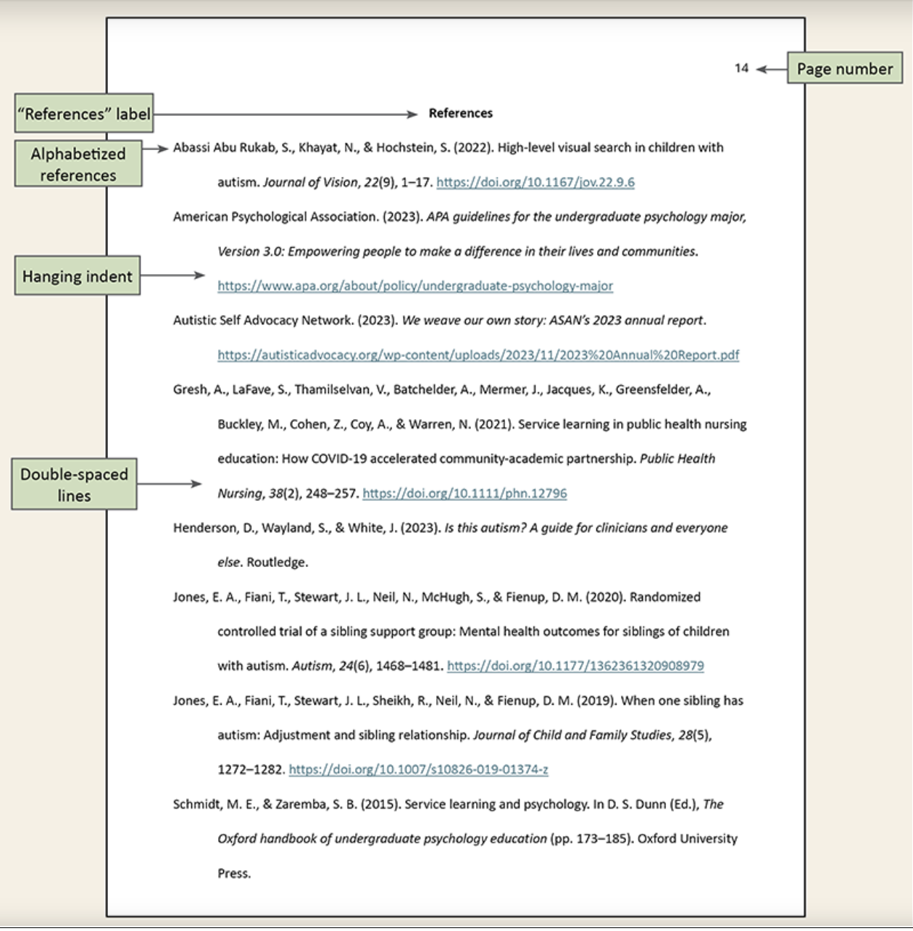

Video Explanations
https://www.youtube.com/watch?v=oX5lCmFpCvY
https://www.youtube.com/watch?v=pCC6jLkyJmg
Websites
https://owl.purdue.edu/owl/research_and_citation/mla_style/mla_formatting_and_style_guide/mla_formatting_and_style_guide.html
https://owl.purdue.edu/owl/research_and_citation/mla_style/mla_formatting_and_style_guide/mla_sample_paper.html

Plagiarism

Plagiarism and Academic Dishonesty
Plagiarism is the unauthorized use or close imitation of the language and thoughts of another author and the representation of them as one’s own original work, as by not crediting the author (Dictionary.com) http://dictionary.reference.com/browse/plagiarism

Plagiarism can be done either intentionally or accidentally. Regardless, it is an academic offence that carries with it varying levels of consequences – from a mark of zero for work submitted to expulsion from the course and/or on-line program. Plagiarism takes various forms: copying another’s work, not citing another’s original work, cutting and pasting from the internet and claiming the work as your own, allowing other students to copy and submit your work as their own, and so on. It is YOUR RESPONSIBILITY to be aware of the rules around using and citing other people’s work.

Many excellent websites exist that can help answers questions about plagiarism. Here are a few examples:
http://www.plagiarism.org/
http://www.grammarly.com/
http://www.englishclub.com/writing/plagiarism.htm
http://australianhelp.com/plagiarism

If you are uncertain as to whether you may be plagiarizing someone’s work, check with your teacher or consult the many websites that outline the rules.

If a student is found to have submitted plagiarized work, the Delta Access teacher will notify both the student and Delta Access administration to document the violation and to determine further consequences. Repeated occurrences of plagiarism will likely result in a final mark of “Failure” in the specific on-line course.

Reporting

Weekly Progress Reports
These be sent to both students and parents through the Moodle website. These reports are sent via email and are based on information provided on course introduction forms. Please make sure you Delta Access profile is up to date with this information.

Report Cards
These will be issued for the in late November, January, March, June and early August to meet the needs of post-secondary admissions. Students needing marks for post-secondary must complete the course within the guidelines provided by teachers, so their marks are uploaded for transcripts.

These reports are available for Delta School District students on our student management system. For those not attending one of our high schools. Please call our Continuing Education office 604-940-5550 to receive a copy.

Only students who have completed the activation assignment requirement for the course will get report cards by the term deadlines outlined by their teachers. Even if you are getting progress reports you are not considered an active (official student) until this is met. For this course, Module One must be submitted and assessed for the activity requirement to be met.

Course reports are based on only what has been submitted for the Fall until April 1st and for the Spring/Summer until July 15th. At this time, all missing assignments will count in grade calculations; this gives students a realistic picture of current course standings.

It is important when viewing report cards and progress reports up until this point that the amount of the course completed is taking into consideration. (ie. 90% standing in a course that is only 10% complete is very different than 90% in a course that is 80% complete).

Contacting your Teacher
Ms. Duggan is available to answer your questions and help you if you are struggling. Please email me at tduggan@deltalearns.ca and I will get back to you within 24 hours. Messaging through the course may have a longer response time.

When you email me, please be sure to tell me your legal name, your course title and level, eg. Your Name - IFR 11.

If you have any concerns that cannot be addressed by your teacher, please contact Delta Access directly at 604-599-6398 or email the Delta Access Principal Bill Tereposky. Email: btereposky@deltaschools.ca.

Frequently asked questions: https://deltalearns.ca/deltaaccess/faq/

Booking a test: https://deltalearns.ca/deltaaccess/book-a-test/

